Spa Service

Use-Case Specification: Use-Case Booking

Version 1.0

Revision History

|  |  |  |  |
| --- | --- | --- | --- |
| **Date** | **Version** | **Description** | **Author** |
| <dd/mmm/yy> | <x.x> | <details> | <name> |
|  |  |  |  |
|  |  |  |  |
|  |  |  |  |

Table of Contents

1. Use-case Model 4

2. Use-case Specifications 4

2.1 Use-case: Booking Service 4

2.2 Use-case: Create a new account 5

# Use-case Model (Mô hình use-case)

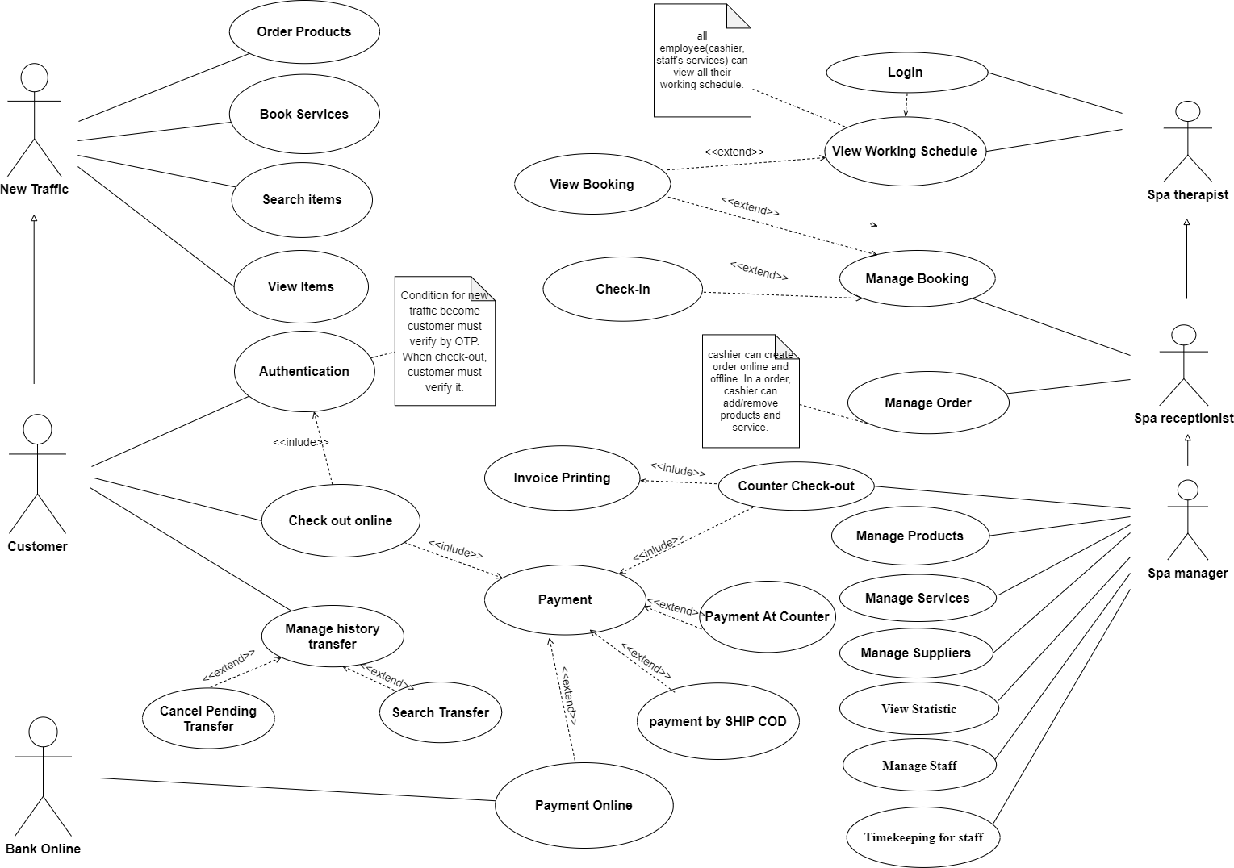

# Use-case Specifications (Đặc tả use-case)

## Use-case: Booking Service

|  |  |
| --- | --- |
| Use case Name  (Tên use-case) | Booking Service |
| Brief description  (Mô tả) | This use case describes how the Customer can booking Spa’s service |
| Actors  (Actors) | Customer |
| Basic Flow  (Luồng cơ bản) | 1. System display list booking service 2. Customer choice services booking 3. System requires customer choose date time booking 4. System requires customer input OTP for verifying booking   4.1 If customer confirm success, the system store booking service into database, and display message “Booking Succes“ + information of booking  4.2 If customer does not confirm success, the system display a message “Booking Error” and requires OTP again |
| Alternative Flows  (Các luồng thay thế) | If the system fails to book, customer can call the system to book an appointment in advance |
| Pre-conditions  (Điều kiện đầu vào) | PRE-1: Service booking choices existed on platform  PRE-2: Service booking choices are not larger than 3 |
| Post-conditions  (Điều kiện đầu ra) | POST-1: Successfully store booking service in database  POST-2: Customer receive code check-in |

## Use-case: Manage Booking Status

|  |  |
| --- | --- |
| Use case Name  (Tên use-case) | Booking Status |
| Brief description  (Mô tả) | This use case describes how the Status when Customers request a Booking Service |
| Actors  (Actors) | Customer, Employee |
| Basic Flow  (Luồng cơ bản) | 1. Customer successfully created a booking order. Booking Status = Active. 2. Server received Booking ID 3. Server send the Booking Order to be viewed and update by Employee 4. When Customer and Employee confirm that Customer has come to spa and used the spa's services. The system will confirm the booking status has been “completed”. |
| Alternative Flows  (Các luồng thay thế) | If Booking Status is not confirmed on time, The system will automatically confirm that Booking Status has “expired”.  If If the customer cancels Booking Services. After being confirmed by customers and employees. The system will confirm that Booking Status has been “canceled”. |
| Pre-conditions  (Điều kiện đầu vào) | Booking Order have been made by the customer of Spa services. |
| Post-conditions  (Điều kiện đầu ra) | POST-1: Successfully store booking service in database.  POST-2: Customer will receive notification when Booking Status ends. |